IFT 166 Introduction to Internet Networking
Lab 4
The “Hub”

After you complete each step, put a ‘√’ or ‘x’ in the completed box
Using Packet Tracer, we can use a hub to show how Ethernet operates in a shared environment where every device is connected to a hub. When the frames hit the hub, the hub will broadcast the frame out every port that is active.
- Create the following topology in Packet Tracer.
Make sure add the IP addresses as shown to PCs 2 and PC 5.
You can accept the default subnet mask
(the subnet mask will be explained in later presentations)
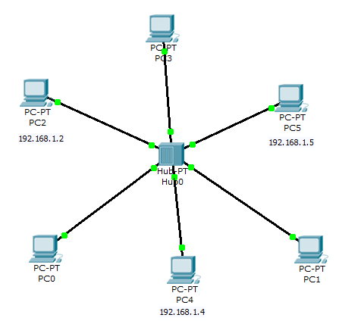



- Open PC2 and the click on the command prompt window.
For PC2 to communicate with PC5, it must know the MAC address of PC5.
How do we know if PC2 knows the MAC address of PC5?
We do not know so we can use the arp – a command which will display our ARP table.
The ARP table will show us what MAC addresses we know.
As you see when you run the command on PC2, it does not know any MAC addresses.
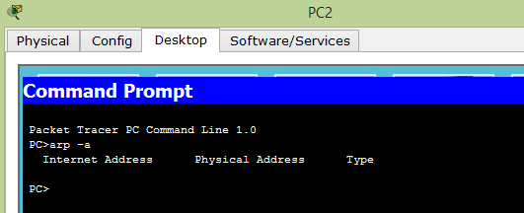



- For PC2 to communicate with PC5, an ARP broadcast needs to be broadcast on the network so the PC can find the MAC address of PC5.
We can see this through simulation mode in Packet Tracer.
Go to simulation mode (bottom right corner) and make sure that all the filters are turned on (have a check mark beside them).

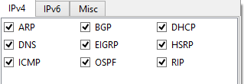



- We will initially try and ping PC5 from PC2 and then PC5 will reply to PC2 (all this happen via 2 protocols i.e. ARP (resolve MAC address) & ICMP).
We will also be able to see the broadcast nature of the network with the hub and ARP protocol.
Send a message from PC2 to PC5 and see this in action (using the “Add simple PDU”, as you did in lab 3).
As you can see, we want to Ping and ARP is the first thing that needs to happen.

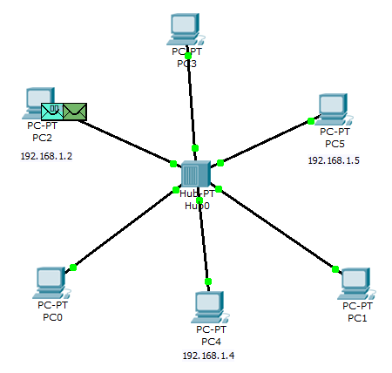

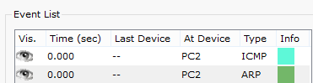



- Click capture forward and the ARP packet goes to the hub.

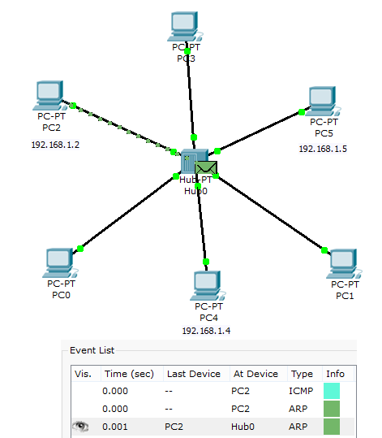


- It is a broadcast packet. By clicking on the packet, we can see it’s an ARP packet, source mac address, destination MAC address (FFFF.FFF.FFFF) and the target address is zero (we do not know the targets MAC address yet), the hub by its nature would send to everybody anyway.
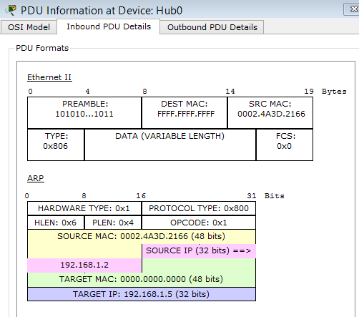



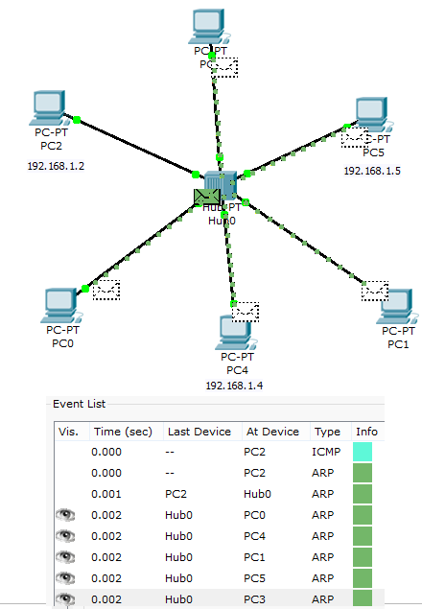
- Close the window and hit capture forward again and you can see its broadcast to every computer on the network.


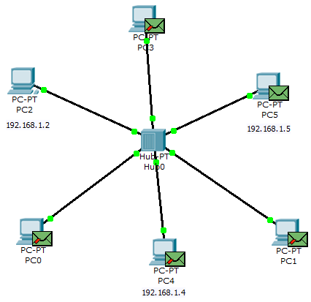
- Only 1 computer should replay which should be PC5. The ARP request was who has the MAC address for 192.168.1.5? PC5 has that MAC address and so replied. The other PCs dropped the ARP broadcast.
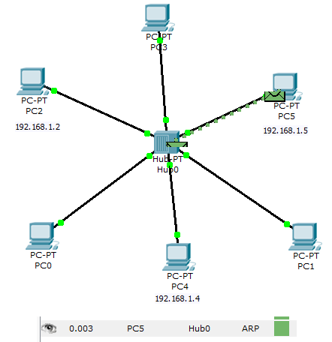



- The hub then broadcasts the response to every computer on the network.

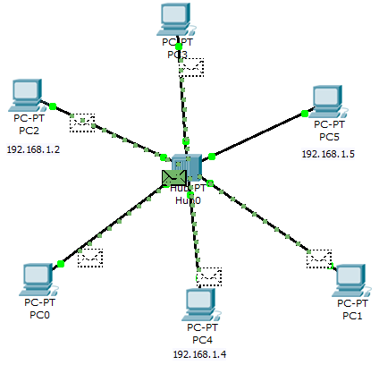


- All other computers drop that frame, and PC2 is the one that accepts it. Now PC2 knows the MAC address of PC5. Check by rerunning the ARP command on PC2.
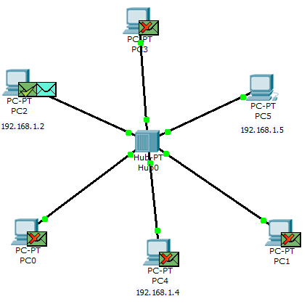

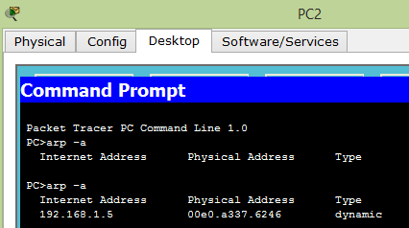



- Now PC2 can ping (ICMP) PC5. Does PC5 know the MAC address of PC2…check with the ARP command on PC5.
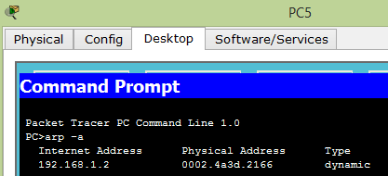

- Hit capture forward and it should be an ICMP packet hitting the hub and then hub will broadcast it everywhere.



- Then click capture forward again to send it back each time only PC5 and PC2 will accept the frame.
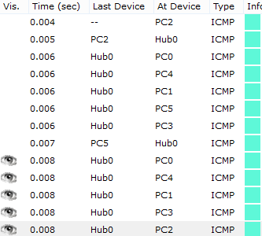



- What would happen if 2 PCS sent a packet to each other at the same time? We will demonstrate that now. Reset your simulation (delete any current events). We will send a packet from PC2 to PC5 and at the same time send a packet from PC4 to PC2. So we have 2 pings that will happen at the same time. PC4 needs to do an APR but no matter.
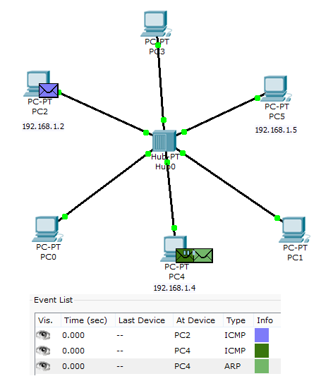



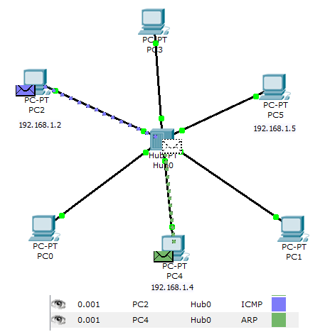
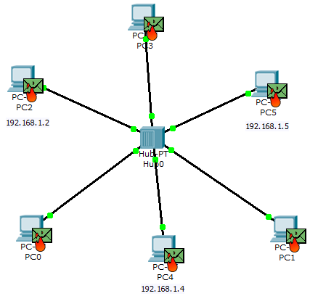
- Hit capture forward and they both it the hub at the same time, and capture forward again and you can see that has been a collision and all of the frames are on fire.



- A collision occurred as two computers tried to send at the same time. Sending devices will sense the collision by the raised amount of voltage on the wire and they will both send out a jammed signal will go to all devices in the network and tell every device to stop sending and a back off algorithm is run (generates a random amount of time for everyone to stop sending and whoever has the shortest time can start sending first).


